**Отчет по лабораторной работе №5** по курсу фундаментальная информатика

Студент группы М8О-101Б-20 Ядров Артем Леонидович, № по списку 28

Контакты www, e-mail, icq, skype temayadrow@gmail.com

Работа выполнена: « » ____________201___г.

Преподаватель: _______ каф. 806 ________________________

Входной контроль знаний с оценкой _____________________

Отчет сдан « » _________201 __ г., итоговая оценка _____

Подпись преподавателя ________________

* 1. **Тема:** Программирование машин Тьюринга _______________________________________________________________________________________________

1. **Цель работы:** Составить программу в четвертах по условию задачи ____________________ _____

_________________________________________________________________________________________________

_________________________________________________________________________________________________

_________________________________________________________________________________________________

1. **Задание** (*вариант №*51 )**:** Проверить делимость числа на 9 ________________________________________

_________________________________________________________________________________________________

_________________________________________________________________________________________________

_________________________________________________________________________________________________

_________________________________________________________________________________________________

_________________________________________________________________________________________________

1. **Оборудование** (лабораторное):

ЭВМ Intel Pentium G2140, процессор ____3.30 GHz __, имя узла сети _Cameron_______ с ОП __8096________ Мб, НМД __7906_____ Мб. Терминал __ASUS___ адрес ___dev/pets/3_______. Принтер _________________________

Другие устройства ________________________________________________________________________________

_________________________________________________________________________________________________

*Оборудование ПЭВМ студента, если использовалось:*

Процессор __Intel core i5 2.60 GHz_ с ОП __8096_ Мб, НМД _ 131072_ Мб. Монитор _______dell_____________

Другие устройства ________________________________________________________________________________

_________________________________________________________________________________________________

1. **Программное обеспечение (лабораторное):**

Операционная система семейства ___Unix____, наименование _____Ubuntu____________ версия __4.15.0______

интерпретатор команд ____bash________ версия ___4.4.20____

Система программирования _______JDT_______________________________________ версия _____5 _________

Редактор текстов _____emacs________________________________________________ версия _25.2.2 _________

Утилиты операционной системы ________________________________ ____________________________________

_________________________________________________________________________________________________

Прикладные системы и программы VTM-diagram ______________________

Местонахождение и имена файлов программ и данных__stud/208104 ____________________________________

_________________________________________________________________________________________________

*Программное обеспечение ЭВМ студента, если использовалось:*

Операционная система семейства ___Unix____, наименование __Fedora____________ версия ___32 __________

интерпретатор команд ____bash________ версия __5.0.17____.

Система программирования _______________JDT_________________________________версия ______5________

Редактор текстов _____emacs________________________________________________ версия _25.2.2 _________

Утилиты операционной системы ____________________________________________________________________

_________________________________________________________________________________________________

Прикладные системы и программы **___** VTM-diagram

_________________________________________________________________________________________________

Местонахождение и имена файлов программ и данных на домашнем компьютере ______home/Temich _________

_________________________________________________________________________________________________

**6. Идея, метод, алгоритм** решения задачи(в формах:словесной,псевдокода,графической[блок-схема,диаграмма,рисунок,таблица] или формальные спецификации с пред- и постусловиями)

1. Создание текущего остатка деления суммы цифр числа на 9 (в самом начале 0)
2. Проход от 0 до цифры
3. Замена цифры на «-» (кроме 9 и 0, т. к. не изменяют остаток)
4. Замена текущего остатка деления суммы цифр числа на 9
5. Возвращение от цифры остатка до знака «-» и замена знака на цифру
6. Смещение на один символ влево
7. Повторение пунктов 3-6 до тех пор, пока очередной символ не станет пробелом
8. Возвращение к остатку
9. Проверка остатка. Если остаток равен 0, то число делится на 9, в противном случае не делится
10. Замена цифры остатка на «1» в случае делимости числа, на «0» - в противном случае
11. Смещение на один символ вправо
12. Конец программы
13. **Сценарий выполнения работы** [план работы,первоначальный текст программы в черновике(можно на отдельном листе)итесты либо соображения по тестированию].

**Тесты:**

1. **<** 0 **> → <** 0 1 **>**
2. **<** 9 **> → <** 9 1 **>**
3. **<** 1234567890 **> → <** 1234567890 1 **>**
4. **<** 123 **>** *→* **<** 1230 **>**

*Пункты 1-7 отчета составляются сторого до начала лабораторной работы.*

*Допущен к выполнению работы.* **Подпись преподавателя****_____________________**

1. **Распечатка протокола** (подклеить листинг окончательного варианта программы с тестовыми примерами,подписанныйпреподавателем).

00, ,>,01

01, ,0,02 **#вывод начального 0**

02,0,<,02

02, ,<,03

03,9,<,03

03,0,<,03

03,8,-,80

03,7,-,70

03,6,-,60

03,5,-,50

03,4,-,40

03,3,-,30

03,2,-,20

03,1,-,10

03, ,>,04 **#конец числа**

04,9,>,04

04,8,>,04

04,7,>,04

04,6,>,04

04,5,>,04

04,4,>,04

04,3,>,04

04,2,>,04

04,1,>,04

04,0,>,04

04, ,>,05

05, ,>,05

05,0,1,06 **#вывод результата**

05,1,0,06

05,2,0,06

05,3,0,06

05,4,0,06

05,5,0,06

05,6,0,06

05,7,0,06

05,8,0,06

06,1,>,06 **#конец программы**

06,0,>,06

80,-,>,80 **#обработка 8**

80,9,>,80

80,8,>,80

80,7,>,80

80,6,>,80

80,5,>,80

80,4,>,80

80,3,>,80

80,2,>,80

80,1,>,80

80,0,>,80

80, ,>,81

81,0,8,82

81,1,0,82

81,2,1,82

81,3,2,82

81,4,3,82

81,5,4,82

81,6,5,82

81,7,6,82

81,8,7,82

82,9,<,82

82,8,<,82

82,7,<,82

82,6,<,82

82,5,<,82

82,4,<,82

82,3,<,82

82,2,<,82

82,1,<,82

82,0,<,82

82, ,<,82

82,-,8,83

83,8,<,03

70,-,>,70 **#обработка 7**

70,9,>,70

70,8,>,70

70,7,>,70

70,6,>,70

70,5,>,70

70,4,>,70

70,3,>,70

70,2,>,70

70,1,>,70

70,0,>,70

70, ,>,71

71,0,7,72

71,1,8,72

71,2,0,72

71,3,1,72

71,4,2,72

71,5,3,72

71,6,4,72

71,7,5,72

71,8,6,72

72,9,<,72

72,8,<,72

72,7,<,72

72,6,<,72

72,5,<,72

72,4,<,72

72,3,<,72

72,2,<,72

72,1,<,72

72,0,<,72

72, ,<,72

72,-,7,73

73,7,<,03

60,-,>,60 **#обработка 6**

60,9,>,60

60,8,>,60

60,7,>,60

60,6,>,60

60,5,>,60

60,4,>,60

60,3,>,60

60,2,>,60

60,1,>,60

60,0,>,60

60, ,>,61

61,0,6,62

61,1,7,62

61,2,8,62

61,3,0,62

61,4,1,62

61,5,2,62

61,6,3,62

61,7,4,62

61,8,5,62

62,9,<,62

62,8,<,62

62,7,<,62

62,6,<,62

62,5,<,62

62,4,<,62

62,3,<,62

62,2,<,62

62,1,<,62

62,0,<,62

62, ,<,62

62,-,6,63

63,6,<,03

50,-,>,50 **#обработка 5**

50,9,>,50

50,8,>,50

50,7,>,50

50,6,>,50

50,5,>,50

50,4,>,50

50,3,>,50

50,2,>,50

50,1,>,50

50,0,>,50

50, ,>,51

51,0,5,52

51,1,6,52

51,2,7,52

51,3,8,52

51,4,0,52

51,5,1,52

51,6,2,52

51,7,3,52

51,8,4,52

52,9,<,52

52,8,<,52

52,7,<,52

52,6,<,52

52,5,<,52

52,4,<,52

52,3,<,52

52,2,<,52

52,1,<,52

52,0,<,52

52, ,<,52

52,-,5,53

53,5,<,03

40,-,>,40 **#обработка 4**

40,9,>,40

40,8,>,40

40,7,>,40

40,6,>,40

40,5,>,40

40,4,>,40

40,3,>,40

40,2,>,40

40,1,>,40

40,0,>,40

40, ,>,41

41,0,4,42

41,1,5,42

41,2,6,42

41,3,7,42

41,4,8,42

41,5,0,42

41,6,1,42

41,7,2,42

41,8,3,42

42,9,<,42

42,8,<,42

42,7,<,42

42,6,<,42

42,5,<,42

42,4,<,42

42,3,<,42

42,2,<,42

42,1,<,42

42,0,<,42

42, ,<,42

42,-,4,43

43,4,<,03

30,-,>,30 **#обработка 3**

30,9,>,30

30,8,>,30

30,7,>,30

30,6,>,30

30,5,>,30

30,4,>,30

30,3,>,30

30,2,>,30

30,1,>,30

30,0,>,30

30, ,>,31

31,0,3,32

31,1,4,32

31,2,5,32

31,3,6,32

31,4,7,32

31,5,8,32

31,6,0,32

31,7,1,32

31,8,2,32

32,9,<,32

32,8,<,32

32,7,<,32

32,6,<,32

32,5,<,32

32,4,<,32

32,3,<,32

32,2,<,32

32,1,<,32

32,0,<,32

32, ,<,32

32,-,3,33

33,3,<,03

20,-,>,20 **#обработка 2**

20,9,>,20

20,8,>,20

20,7,>,20

20,6,>,20

20,5,>,20

20,4,>,20

20,3,>,20

20,2,>,20

20,1,>,20

20,0,>,20

20, ,>,21

21,0,2,22

21,1,3,22

21,2,4,22

21,3,5,22

21,4,6,22

21,5,7,22

21,6,8,22

21,7,0,22

21,8,1,22

22,9,<,22

22,8,<,22

22,7,<,22

22,6,<,22

22,5,<,22

22,4,<,22

22,3,<,22

22,2,<,22

22,1,<,22

22,0,<,22

22, ,<,22

22,-,2,23

23,2,<,03

10,-,>,10 **#обработка 1**

10,9,>,10

10,8,>,10

10,7,>,10

10,6,>,10

10,5,>,10

10,4,>,10

10,3,>,10

10,2,>,10

10,1,>,10

10,0,>,10

10, ,>,11

11,0,1,12

11,1,2,12

11,2,3,12

11,3,4,12

11,4,5,12

11,5,6,12

11,6,7,12

11,7,8,12

11,8,0,12

12,9,<,12

12,8,<,12

12,7,<,12

12,6,<,12

12,5,<,12

12,4,<,12

12,3,<,12

12,2,<,12

12,1,<,12

12,0,<,12

12, ,<,12

12,-,1,13

13,1,<,03

**Диаграмма для программы.**

1. **Основная программа.**

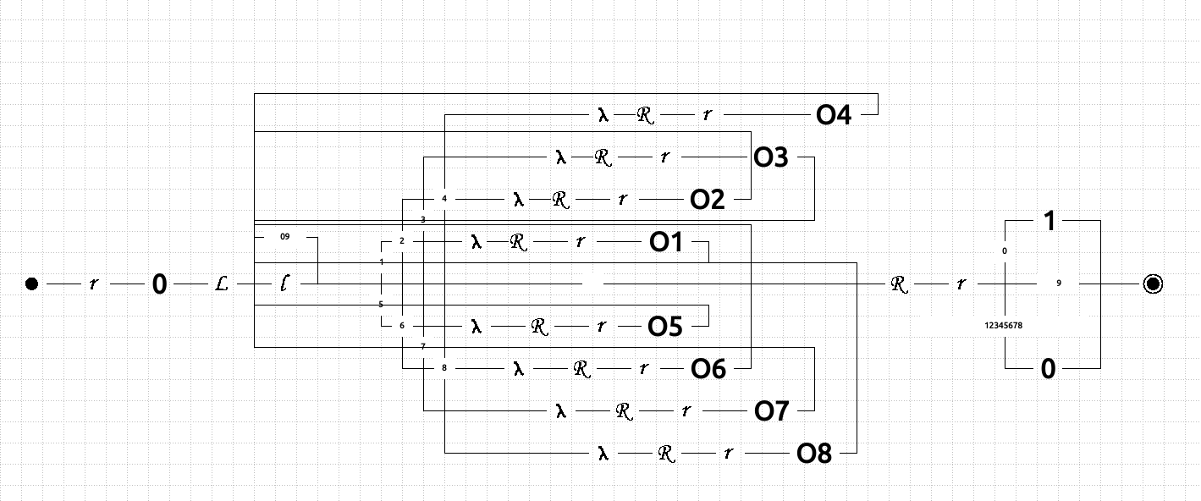

1. **Подпрограмма О1.**

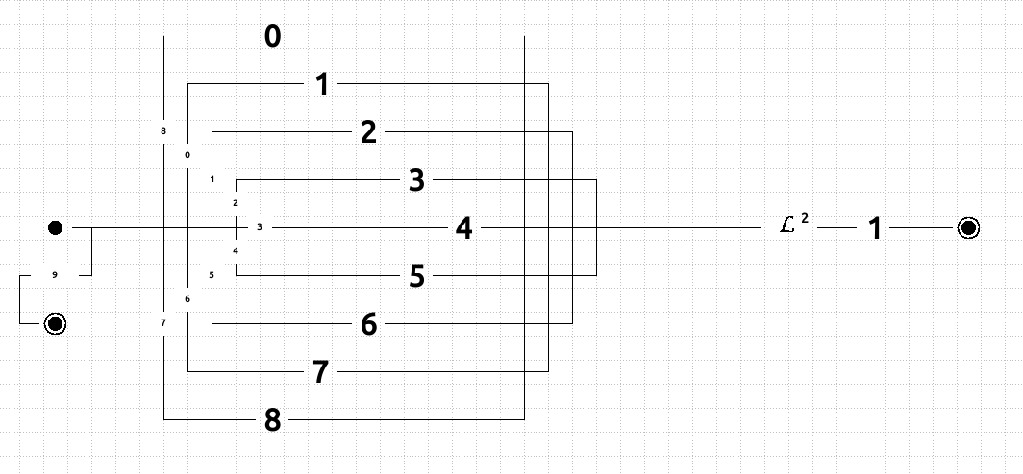

1. **Подпрограмма О2.**

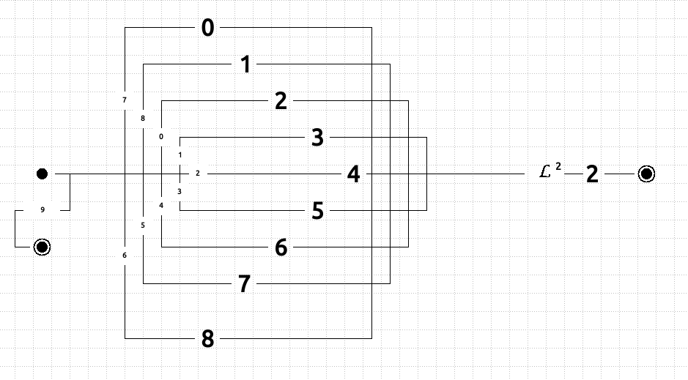

1. 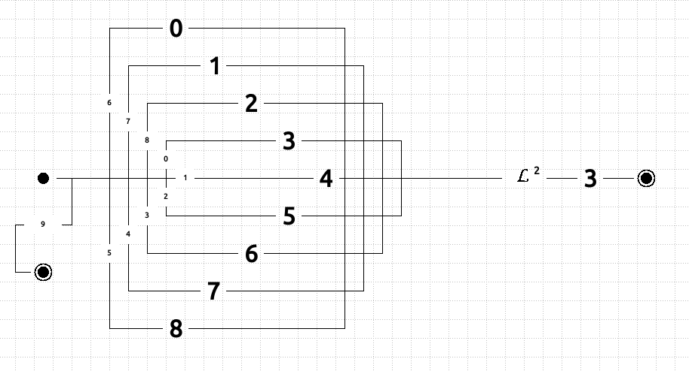**Подпрограмма О3.**
2. **Подпрограмма О4.**
3. 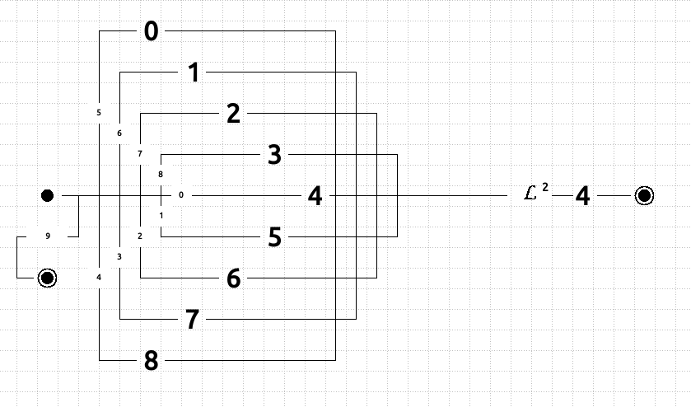**Подпрограмма О5.**
4. 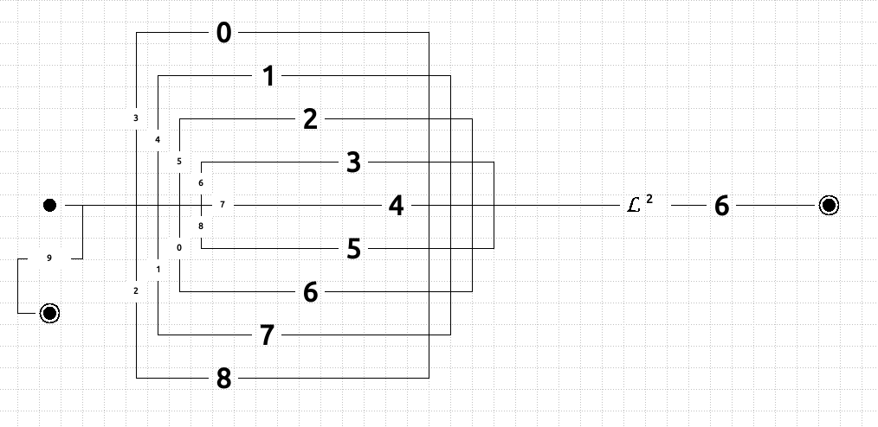**Подпрограмма О6.**

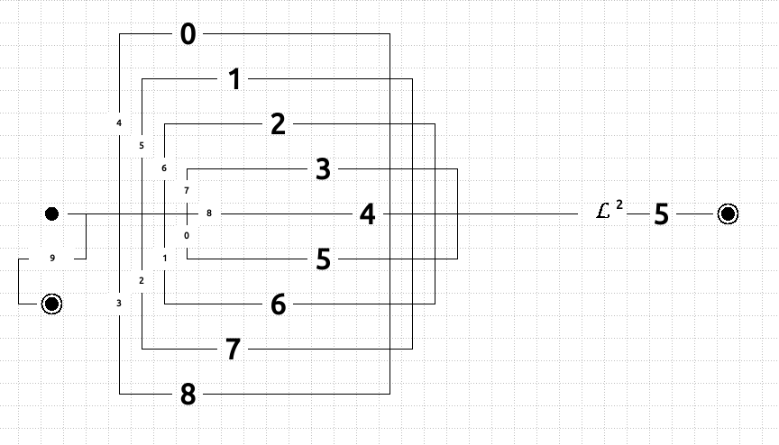

1. **Подпрограмма О7.**
2. 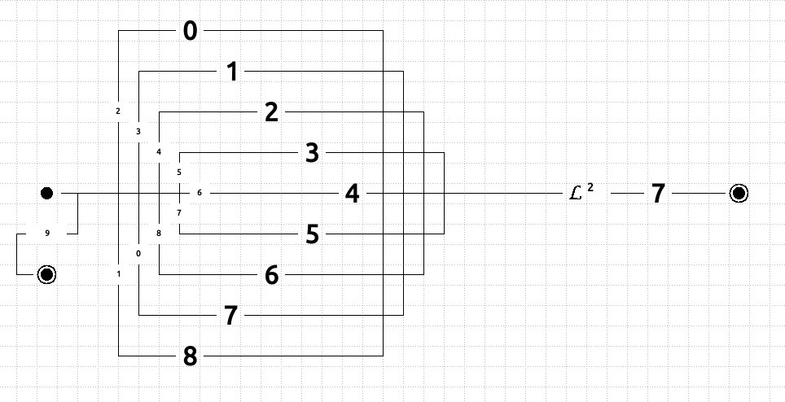**Подпрограмма О8.**

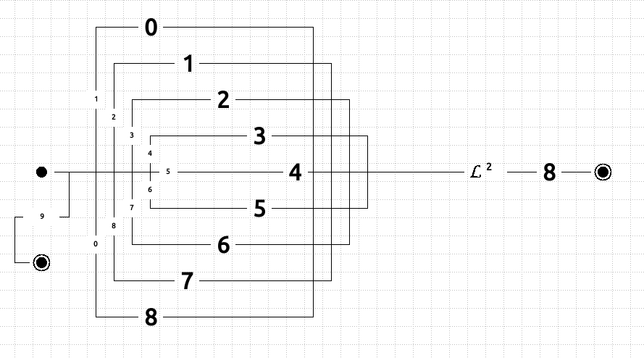

**[Temich@localhost ~]$ turun l5.tu tests**

**00, ,>,01 09,6,<,09 16,6,3,17 24,0,4,25 31,4,>,31**

**01, ,0,02 09,5,<,09 16,7,4,17 24,1,5,25 31,3,>,31**

**02,0,<,02 09,4,<,09 16,8,5,17 24,2,6,25 31,2,>,31**

**02, ,<,03 09,3,<,09 17,9,<,17 24,3,7,25 31,1,>,31**

**03,9,<,03 09,2,<,09 17,8,<,17 24,4,8,25 31,0,>,31**

**03,0,<,03 09,1,<,09 17,7,<,17 24,5,0,25 31, ,>,32**

**03,8,-,07 09,0,<,09 17,6,<,17 24,6,1,25 32,0,2,33**

**03,7,-,11 09, ,<,09 17,5,<,17 24,7,2,25 32,1,3,33**

**03,6,-,15 09,-,8,10 17,4,<,17 24,8,3,25 32,2,4,33**

**03,5,-,19 10,8,<,03 17,3,<,17 25,9,<,25 32,3,5,33**

**03,4,-,23 11,-,>,11 17,2,<,17 25,8,<,25 32,4,6,33**

**03,3,-,27 11,9,>,11 17,1,<,17 25,7,<,25 32,5,7,33**

**03,2,-,31 11,8,>,11 17,0,<,17 25,6,<,25 32,6,8,33**

**03,1,-,35 11,7,>,11 17, ,<,17 25,5,<,25 32,7,0,33**

**03, ,>,04 11,6,>,11 17,-,6,18 25,4,<,25 32,8,1,33**

**04,9,>,04 11,5,>,11 18,6,<,03 25,3,<,25 33,9,<,33**

**04,8,>,04 11,4,>,11 19,-,>,19 25,2,<,25 33,8,<,33**

**04,7,>,04 11,3,>,11 19,9,>,19 25,1,<,25 33,7,<,33**

**04,6,>,04 11,2,>,11 19,8,>,19 25,0,<,25 33,6,<,33**

**04,5,>,04 11,1,>,11 19,7,>,19 25, ,<,25 33,5,<,33**

**04,4,>,04 11,0,>,11 19,6,>,19 25,-,4,26 33,4,<,33**

**04,3,>,04 11, ,>,12 19,5,>,19 26,4,<,03 33,3,<,33**

**04,2,>,04 12,0,7,13 19,4,>,19 27,-,>,27 33,2,<,33**

**04,1,>,04 12,1,8,13 19,3,>,19 27,9,>,27 33,1,<,33**

**04,0,>,04 12,2,0,13 19,2,>,19 27,8,>,27 33,0,<,33**

**04, ,>,05 12,3,1,13 19,1,>,19 27,7,>,27 33, ,<,33**

**05, ,>,05 12,4,2,13 19,0,>,19 27,6,>,27 33,-,2,34**

**05,0,1,06 12,5,3,13 19, ,>,20 27,5,>,27 34,2,<,03**

**05,1,0,06 12,6,4,13 20,0,5,21 27,4,>,27 35,-,>,35**

**05,2,0,06 12,7,5,13 20,1,6,21 27,3,>,27 35,9,>,35**

**05,3,0,06 12,8,6,13 20,2,7,21 27,2,>,27 35,8,>,35**

**05,4,0,06 13,9,<,13 20,3,8,21 27,1,>,27 35,7,>,35**

**05,5,0,06 13,8,<,13 20,4,0,21 27,0,>,27 35,6,>,35**

**05,6,0,06 13,7,<,13 20,5,1,21 27, ,>,28 35,5,>,35**

**05,7,0,06 13,6,<,13 20,6,2,21 28,0,3,29 35,4,>,35**

**05,8,0,06 13,5,<,13 20,7,3,21 28,1,4,29 35,3,>,35**

**06,1,>,06 13,4,<,13 20,8,4,21 28,2,5,29 35,2,>,35**

**06,0,>,06 13,3,<,13 21,9,<,21 28,3,6,29 35,1,>,35**

**06, ,#,06 13,2,<,13 21,8,<,21 28,4,7,29 35,0,>,35**

**07,-,>,07 13,1,<,13 21,7,<,21 28,5,8,29 35, ,>,36**

**07,9,>,07 13,0,<,13 21,6,<,21 28,6,0,29 36,0,1,37**

**07,8,>,07 13, ,<,13 21,5,<,21 28,7,1,29 36,1,2,37**

**07,7,>,07 13,-,7,14 21,4,<,21 28,8,2,29 36,2,3,37**

**07,6,>,07 14,7,<,03 21,3,<,21 29,9,<,29 36,3,4,37**

**07,5,>,07 15,-,>,15 21,2,<,21 29,8,<,29 36,4,5,37**

**07,4,>,07 15,9,>,15 21,1,<,21 29,7,<,29 36,5,6,37**

**07,3,>,07 15,8,>,15 21,0,<,21 29,6,<,29 36,6,7,37**

**07,2,>,07 15,7,>,15 21, ,<,21 29,5,<,29 36,7,8,37**

**07,1,>,07 15,6,>,15 21,-,5,22 29,4,<,29 36,8,0,37**

**07,0,>,07 15,5,>,15 22,5,<,03 29,3,<,29 37,9,<,37**

**07, ,>,08 15,4,>,15 23,-,>,23 29,2,<,29 37,8,<,37**

**08,0,8,09 15,3,>,15 23,9,>,23 29,1,<,29 37,7,<,37**

**08,1,0,09 15,2,>,15 23,8,>,23 29,0,<,29 37,6,<,37**

**08,2,1,09 15,1,>,15 23,7,>,23 29, ,<,29 37,5,<,37**

**08,3,2,09 15,0,>,15 23,6,>,23 29,-,3,30 37,4,<,37**

**08,4,3,09 15, ,>,16 23,5,>,23 30,3,<,03 37,3,<,37**

**08,5,4,09 16,0,6,17 23,4,>,23 31,-,>,31 37,2,<,37**

**08,6,5,09 16,1,7,17 23,3,>,23 31,9,>,31 37,1,<,37**

**08,7,6,09 16,2,8,17 23,2,>,23 31,8,>,31 37,0,<,37**

**08,8,7,09 16,3,0,17 23,1,>,23 31,7,>,31 37, ,<,37**

**09,9,<,09 16,4,1,17 23,0,>,23 31,6,>,31 37,-,1,38**

**09,8,<,09 16,5,2,17 23, ,>,24 31,5,>,31 38,1,<,03**

**09,7,<,09**

**0 =>**

**0 0 =>**

**0 1 =>**

**0 1**

**Machine stopped successfully**

**9 =>**

**9 0 =>**

**9 1 =>**

**9 1**

**Machine stopped successfully**

**1234567890 =>**

**1234567890 0 =>**

**1234567-90 0 =>**

**1234567-90 8 =>**

**1234567890 8 =>**

**123456-890 8 =>**

**123456-890 6 =>**

**1234567890 6 =>**

**12345-7890 6 =>**

**12345-7890 3 =>**

**1234567890 3 =>**

**1234-67890 3 =>**

**1234-67890 8 =>**

**1234567890 8 =>**

**123-567890 8 =>**

**123-567890 3 =>**

**1234567890 3 =>**

**12-4567890 3 =>**

**12-4567890 6 =>**

**1234567890 6 =>**

**1-34567890 6 =>**

**1-34567890 8 =>**

**1234567890 8 =>**

**-234567890 8 =>**

**-234567890 0 =>**

**1234567890 0 =>**

**1234567890 1 =>**

**1234567890 1**

**Machine stopped successfully**

**123 =>**

**123 0 =>**

**12- 0 =>**

**12- 3 =>**

**123 3 =>**

**1-3 3 =>**

**1-3 5 =>**

**123 5 =>**

**-23 5 =>**

**-23 6 =>**

**123 6 =>**

**123 0 =>**

**123 0**

**Machine stopped successfully**

1. **Дневник отладки** должен содержать дату и время сеансов отладки, и основные события(ошибки в сценарии и программе,нестандартные ситуации) и краткие комментарии к ним. В дневнике отладки приводятся сведения об использовании других ЭВМ, существенном участии преподавателя и других лиц в написании и отладке программы.

|  |  |  |  |  |  |  |
| --- | --- | --- | --- | --- | --- | --- |
| № | Лаб. | Дата | Время | Событие | Действие по исправлению | Примечание |
|  | или |  |  |  |  |  |
|  | дом. |  |  |  |  |  |
|  |  |  |  |  |  |  |

1. **Замечания автора** по существу работы _______________________________________________________________

_________________________________________________________________________________________________________

_________________________________________________________________________________________________________

_________________________________________________________________________________________________________

1. **Выводы**

Я научился писать программы для машины Тьюринга в четверках и строить диаграммы для них. ____________

_________________________________________________________________________________________________________

_________________________________________________________________________________________________________

_________________________________________________________________________________________________________

_________________________________________________________________________________________________________

_________________________________________________________________________________________________________

_________________________________________________________________________________________________________

_________________________________________________________________________________________________________

_________________________________________________________________________________________________________

_________________________________________________________________________________________________________

_________________________________________________________________________________________________________

_________________________________________________________________________________________________________

Недочёты при выполнении задания могут быть устранены следующим образом: ________________________________

_________________________________________________________________________________________________________

_________________________________________________________________________________________________________

_________________________________________________________________________________________________________

_________________________________________________________________________________________________________

_________________________________________________________________________________________________________

Подпись студента _________________